Machine learning Lab Observation
ITA0614
Experiment 6
Write a program to implement Naïve Bayes algorithm in python and to display the results using confusion matrix and accuracy.
Name : HARIHARAN GB
Reg.No : 192412390
Problem 1 : Play Tennis Prediction
Aim
To implement a Categorical Naive Bayes classifier with Laplace smoothing from scratch in Python to predict whether tennis is played on a given day, and to display the result using a confusion matrix and accuracy.
Algorithm
- Load the data set and divide it into a training set and a test set (or use the full table when the data set is small).
- Compute the prior probability P(C) of every class C as the fraction of training samples that belong to the class.
- Estimate the likelihood P(x_i | C) of every feature: use counts with Laplace smoothing for categorical or word features, and the mean and variance of a Gaussian for numerical features.
- For a sample x, apply Bayes theorem with the naive assumption that the features are independent: P(C | x) is proportional to P(C) * P(x_1 | C) * P(x_2 | C) * ... * P(x_n | C) (logarithms are added to avoid underflow).
- Assign the sample to the class with the largest posterior probability.
- Predict every test sample, build the confusion matrix (rows = actual class, columns = predicted class) and compute the accuracy = (sum of diagonal values) / (total samples).
- Use the trained model to predict the class of a new sample.
Program:
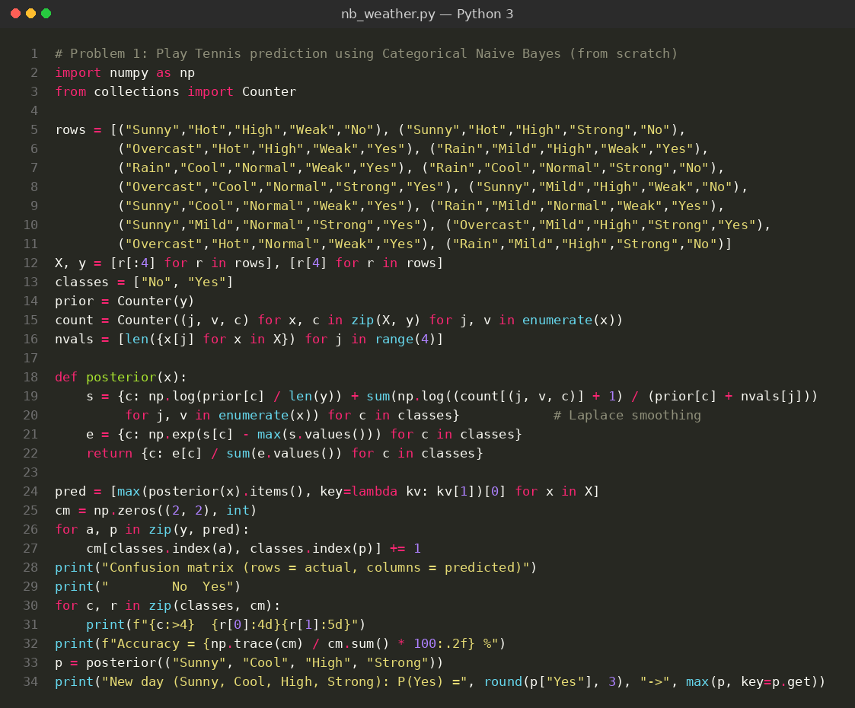
Input
Play Tennis data set: 14 training days with 4 categorical features (Outlook, Temperature, Humidity, Wind) and the target Play (Yes / No). The model is tested on the same 14 days and then on a new day (Sunny, Cool, High, Strong).
Outlook | Temperature | Humidity | Wind | Play
Sunny | Hot | High | Weak | No
Sunny | Hot | High | Strong | No
Overcast | Hot | High | Weak | Yes
Rain | Mild | High | Weak | Yes
Rain | Cool | Normal | Weak | Yes
Rain | Cool | Normal | Strong | No
Overcast | Cool | Normal | Strong | Yes
Sunny | Mild | High | Weak | No
Sunny | Cool | Normal | Weak | Yes
Rain | Mild | Normal | Weak | Yes
Sunny | Mild | Normal | Strong | Yes
Overcast | Mild | High | Strong | Yes
Overcast | Hot | Normal | Weak | Yes
Rain | Mild | High | Strong | No
Output
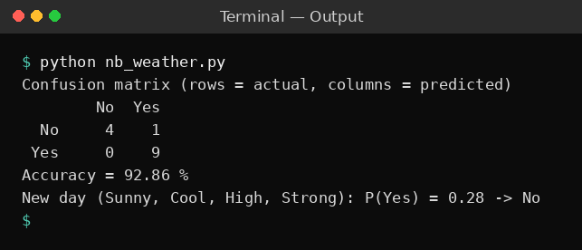
Result
The confusion matrix shows 4 true No, 9 true Yes and 1 No day wrongly predicted as Yes, so 13 of the 14 days are correct and the accuracy is 92.86 %. For the new day (Sunny, Cool, High, Strong) the probability of Yes is 0.28, so the prediction is No (do not play).
Problem 2: Iris Flower Classification
Aim
To implement a Gaussian Naive Bayes classifier from scratch to classify Iris flowers into three species and to display the result using a 3 x 3 confusion matrix and accuracy.
Algorithm
- Load the data set and divide it into a training set and a test set (or use the full table when the data set is small).
- Compute the prior probability P(C) of every class C as the fraction of training samples that belong to the class.
- Estimate the likelihood P(x_i | C) of every feature: use counts with Laplace smoothing for categorical or word features, and the mean and variance of a Gaussian for numerical features.
- For a sample x, apply Bayes theorem with the naive assumption that the features are independent: P(C | x) is proportional to P(C) * P(x_1 | C) * P(x_2 | C) * ... * P(x_n | C) (logarithms are added to avoid underflow).
- Assign the sample to the class with the largest posterior probability.
- Predict every test sample, build the confusion matrix (rows = actual class, columns = predicted class) and compute the accuracy = (sum of diagonal values) / (total samples).
- Use the trained model to predict the class of a new sample.
Program:
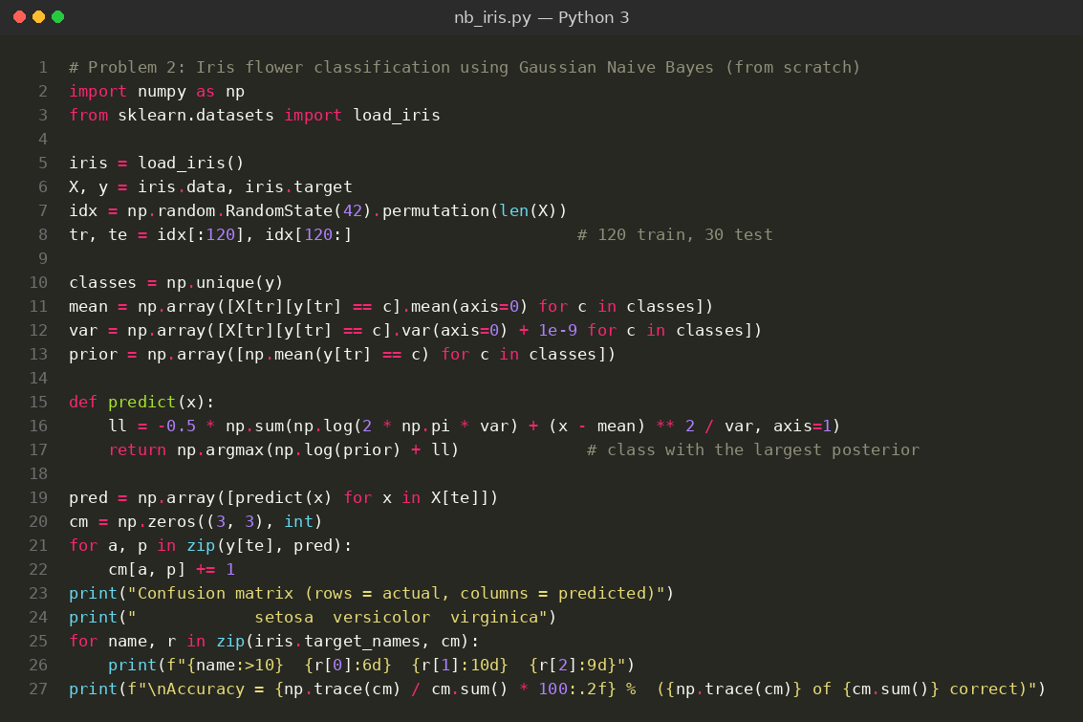
Input
Iris data set (loaded from scikit-learn): 150 samples, 4 features (sepal length, sepal width, petal length, petal width in cm) and 3 classes (setosa, versicolor, virginica). 120 samples are used for training and 30 for testing. A few sample rows are shown below.
Sepal Length | Sepal Width | Petal Length | Petal Width | Class
5.1 | 3.5 | 1.4 | 0.2 | setosa
4.9 | 3.0 | 1.4 | 0.2 | setosa
7.0 | 3.2 | 4.7 | 1.4 | versicolor
6.4 | 3.2 | 4.5 | 1.5 | versicolor
6.3 | 3.3 | 6.0 | 2.5 | virginica
5.8 | 2.7 | 5.1 | 1.9 | virginica
Output
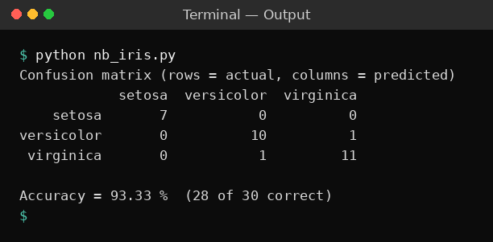
Result
All 7 setosa flowers were classified correctly, 10 of 11 versicolor and 11 of 12 virginica flowers were correct, with one versicolor-virginica confusion in each direction. The accuracy is 93.33 % (28 of 30 test flowers).
Problem 3: Spam Message Detection
Aim
To implement a Multinomial Naive Bayes text classifier with Laplace smoothing to separate spam messages from ham (normal) messages and to display the result using a confusion matrix and accuracy.
Algorithm
- Load the data set and divide it into a training set and a test set (or use the full table when the data set is small).
- Compute the prior probability P(C) of every class C as the fraction of training samples that belong to the class.
- Estimate the likelihood P(x_i | C) of every feature: use counts with Laplace smoothing for categorical or word features, and the mean and variance of a Gaussian for numerical features.
- For a sample x, apply Bayes theorem with the naive assumption that the features are independent: P(C | x) is proportional to P(C) * P(x_1 | C) * P(x_2 | C) * ... * P(x_n | C) (logarithms are added to avoid underflow).
- Assign the sample to the class with the largest posterior probability.
- Predict every test sample, build the confusion matrix (rows = actual class, columns = predicted class) and compute the accuracy = (sum of diagonal values) / (total samples).
- Use the trained model to predict the class of a new sample.
Program:
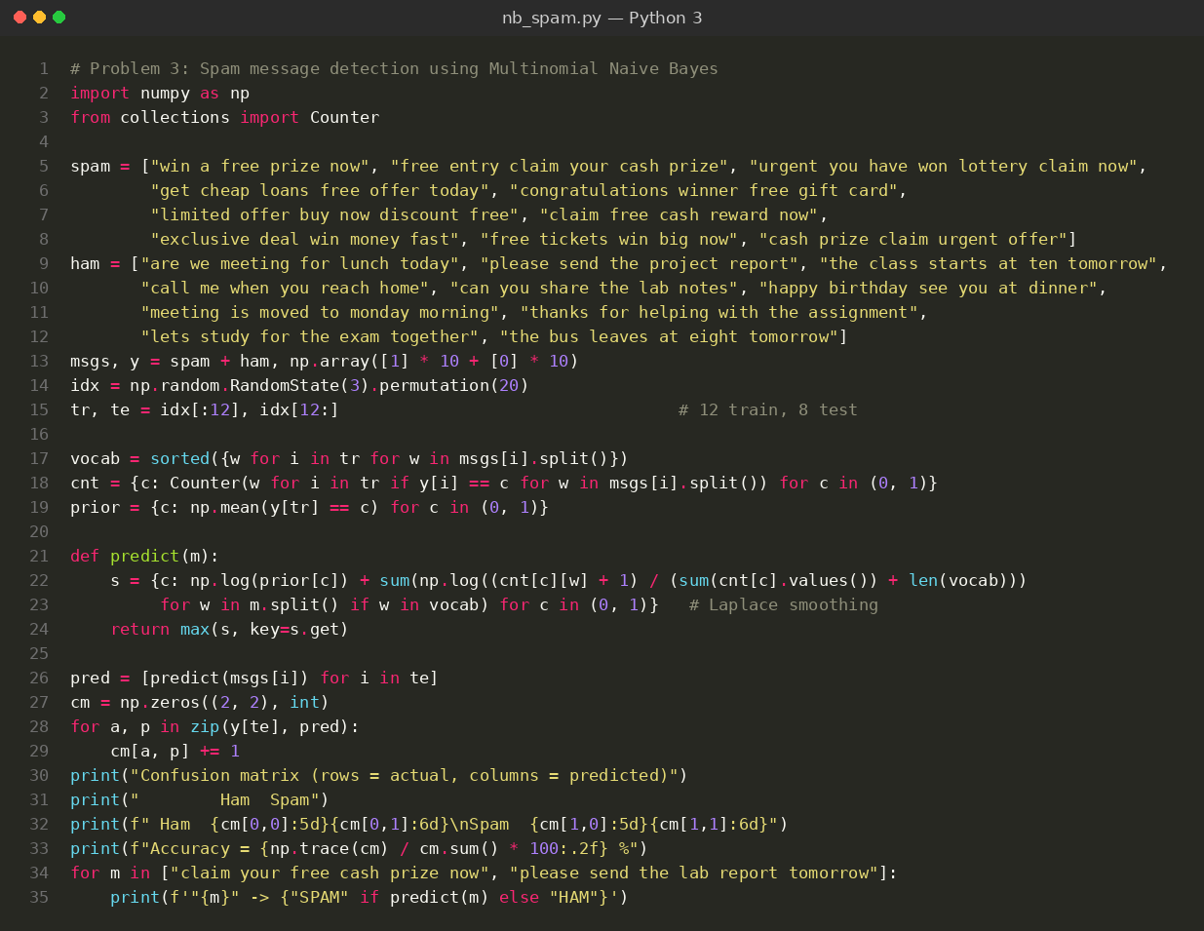
Input
Message data set: 20 short text messages (10 spam and 10 ham). The words of each message are the features. 12 messages are used for training and 8 for testing. Two new messages are also tested. A few sample messages are shown below.
Message | Class
win a free prize now | Spam
free entry claim your cash prize | Spam
urgent you have won lottery claim now | Spam
are we meeting for lunch today | Ham
please send the project report | Ham
the class starts at ten tomorrow | Ham
Output
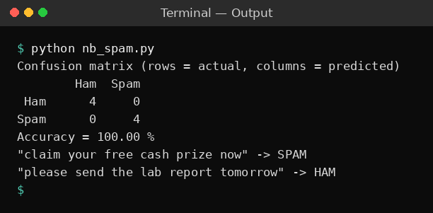
Result
All 4 ham and all 4 spam test messages were classified correctly, so the confusion matrix is diagonal and the accuracy is 100 %. The new message "claim your free cash prize now" is predicted SPAM and "please send the lab report tomorrow" is predicted HAM.
Problem 4: Breast Cancer Diagnosis
Aim
To use the Gaussian Naive Bayes classifier of scikit-learn to classify tumours as malignant or benign and to display the result using the confusion matrix, accuracy, precision and recall.
Algorithm
- Load the data set and divide it into a training set and a test set (or use the full table when the data set is small).
- Compute the prior probability P(C) of every class C as the fraction of training samples that belong to the class.
- Estimate the likelihood P(x_i | C) of every feature: use counts with Laplace smoothing for categorical or word features, and the mean and variance of a Gaussian for numerical features.
- For a sample x, apply Bayes theorem with the naive assumption that the features are independent: P(C | x) is proportional to P(C) * P(x_1 | C) * P(x_2 | C) * ... * P(x_n | C) (logarithms are added to avoid underflow).
- Assign the sample to the class with the largest posterior probability.
- Predict every test sample, build the confusion matrix (rows = actual class, columns = predicted class) and compute the accuracy = (sum of diagonal values) / (total samples).
- Use the trained model to predict the class of a new sample.
Program:
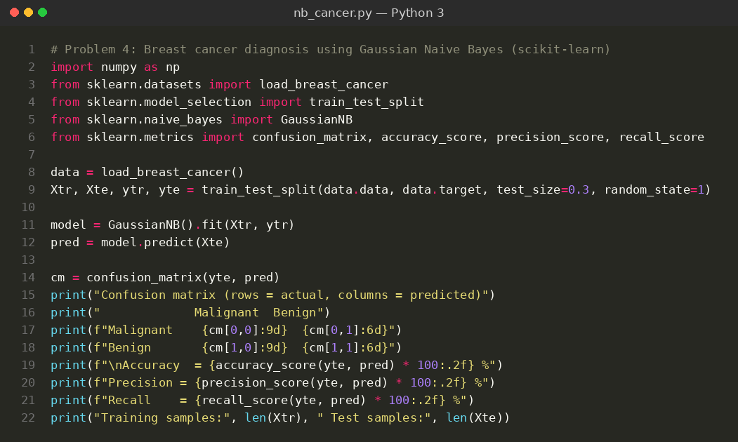
Input
Breast cancer data set (loaded from scikit-learn): 569 samples with 30 numerical features computed from tumour images and 2 classes (malignant, benign). 70 % of the data (398 samples) is used for training and 30 % (171 samples) for testing. A few features and the class of sample rows are shown below.
Mean Radius | Mean Texture | Mean Perimeter | Mean Area | Class
17.99 | 10.38 | 122.8 | 1001.0 | malignant
20.57 | 17.77 | 132.9 | 1326.0 | malignant
19.69 | 21.25 | 130.0 | 1203.0 | malignant
13.54 | 14.36 | 87.46 | 566.3 | benign
13.08 | 15.71 | 85.63 | 520.0 | benign
9.5 | 12.44 | 60.34 | 273.9 | benign
Output
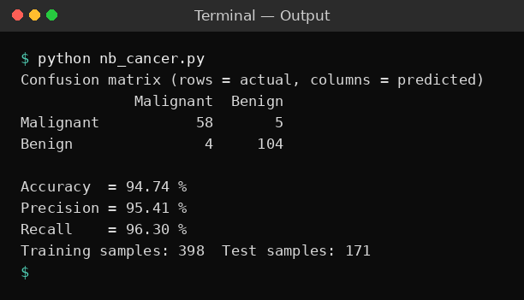
Result
Out of 171 test samples the model classified 58 malignant and 104 benign tumours correctly, with 5 malignant tumours predicted as benign and 4 benign tumours predicted as malignant. The accuracy is 94.74 %, the precision is 95.41 % and the recall is 96.30 %.
Problem 5: Customer Purchase Prediction
Aim
To implement a reusable GaussianNB class with fit, proba and predict methods to predict whether a customer will buy a product, and to display the result using a confusion matrix and accuracy.
Algorithm
- Load the data set and divide it into a training set and a test set (or use the full table when the data set is small).
- Compute the prior probability P(C) of every class C as the fraction of training samples that belong to the class.
- Estimate the likelihood P(x_i | C) of every feature: use counts with Laplace smoothing for categorical or word features, and the mean and variance of a Gaussian for numerical features.
- For a sample x, apply Bayes theorem with the naive assumption that the features are independent: P(C | x) is proportional to P(C) * P(x_1 | C) * P(x_2 | C) * ... * P(x_n | C) (logarithms are added to avoid underflow).
- Assign the sample to the class with the largest posterior probability.
- Predict every test sample, build the confusion matrix (rows = actual class, columns = predicted class) and compute the accuracy = (sum of diagonal values) / (total samples).
- Use the trained model to predict the class of a new sample.
Program:
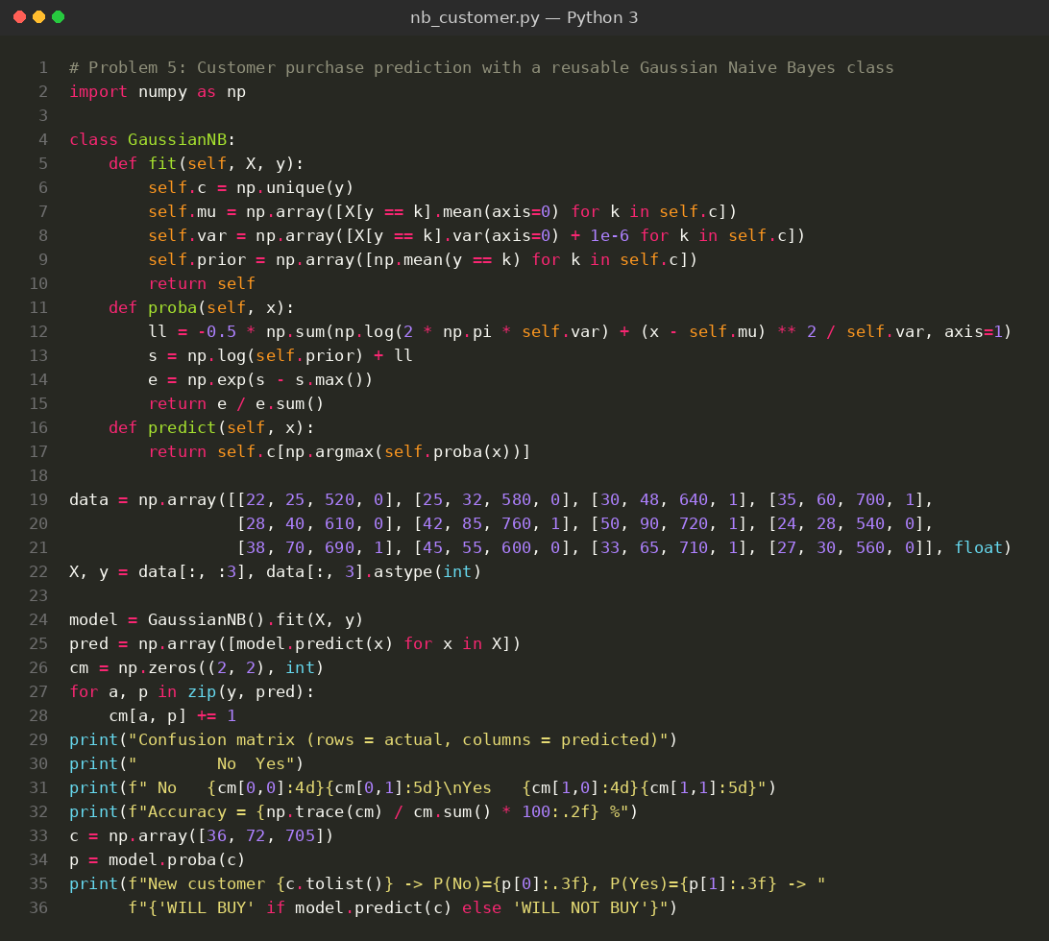
Input
Customer data set: 12 training examples with 3 inputs (Age, Salary in thousands, Credit Score) and the target Purchased (1 = Yes, 0 = No). The model is tested on the training data and on a new customer (36 years, 72k, 705).
Age | Salary (k) | Credit Score | Purchased
22 | 25 | 520 | 0
25 | 32 | 580 | 0
30 | 48 | 640 | 1
35 | 60 | 700 | 1
28 | 40 | 610 | 0
42 | 85 | 760 | 1
50 | 90 | 720 | 1
24 | 28 | 540 | 0
38 | 70 | 690 | 1
45 | 55 | 600 | 0
33 | 65 | 710 | 1
27 | 30 | 560 | 0
Output
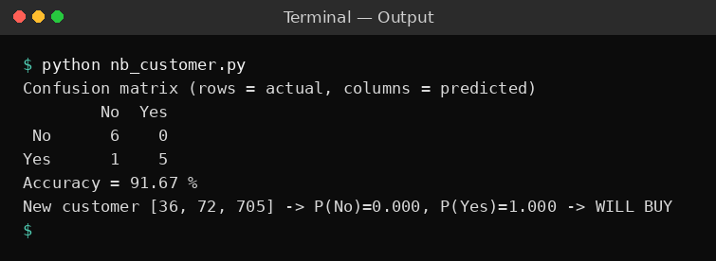
Result
The confusion matrix shows 6 true No and 5 true Yes customers predicted correctly and 1 buyer predicted as No, so the accuracy is 91.67 %. The new customer (36 years, salary 72k, credit score 705) has P(Yes) = 1.000 and is predicted to buy the product.

